

Tokenomics 101 – Analyzing Crypto Economics
School: ............................................................................................................. Campus: .......................................................
Academic Year: ...................... Subject Name: ........................................................... Subject Code: ..........................

Semester: ............... Program: ........................................ Branch: ......................... Specialization: .......................... Date: .....................................
(Learning by Doing and Discovery)

* Coding Phase: Pseudo Code / Flow Chart / Algorithm
- Initialize Token Supply:
  - Define total supply of tokens (e.g., 1,000,000).
- Allocate Tokens:
  - Divide the total supply into categories such as:
    - Team: 20%
    - Investors: 30%
    - Public Sale: 40%
    - Reserve: 10%

- Simulate Circulation:
  - Track how tokens enter the market through staking, trading, or rewards.
- Apply Token Burning (Optional):
  - Remove a small percentage of tokens from circulation to simulate deflation.
- Calculate Market Value:
  - Token price = Market Cap ÷ Circulating Supply
- Display Final Metrics:
  - Show total supply, circulating supply, burned tokens, and token price changes.
Software used
- VS Code.
- MS Word.
- Brave for researching.

* Implementation Phase: Final Output (no error)
Initial Token Supply: 1,000,000

Allocation:

Team: 200,000
Investors: 300,000
Public Sale: 400,000
Reserve: 100,000

After Circulation:

Burned Tokens: 20,000
New Circulating Supply: 980,000 Market Cap: $4,900,000
Token Price: $5.00

Output Example:

Total Supply: 1000000
Tokens Burned: 20000
Circulating Supply: 980000 Current Token Price: $5.00
* Observations:
- Token allocation strategy directly affects token scarcity and investor trust.

- Burning mechanisms reduce total supply, helping increase token value over time.

- Staking rewards motivate long-term participation and reduce market volatility.

- A balanced tokenomics model ensures both early and late participants benefit.

- Inflationary models help maintain liquidity, while deflationary models promote scarcity.

- Projects with transparent and fair tokenomics attract more community engagement.

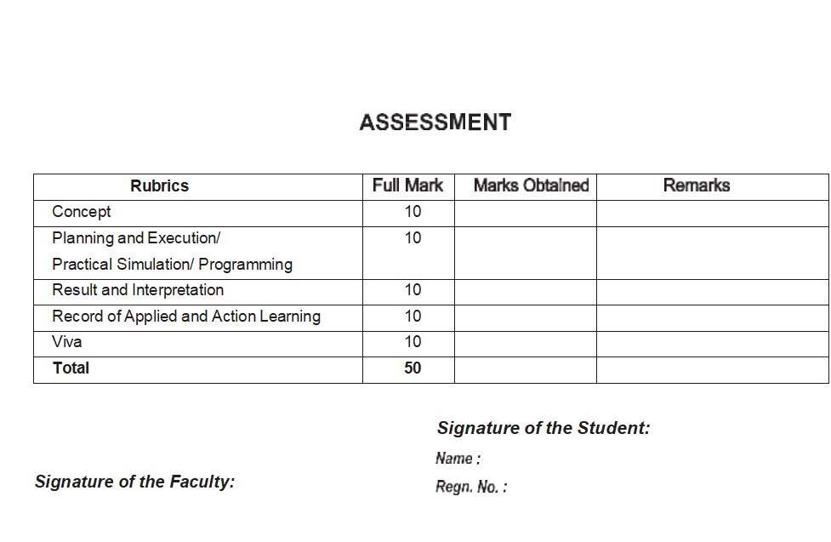
s

